Final Project: Digital Transformation Strategy for a Mid-sized Retail Chain

Step I: Current system assessment
- System architecture overview
The retailer operates approximately 50 U.S. stores and an e-commerce channel on a fragmented legacy architecture. In-store sales use Windows CE-based POS terminals with transaction times exceeding five seconds and card-reader drivers dating from 2009. E-commerce runs on Magento 1.9 with a separate MySQL database and poor mobile performance, including page loads above two seconds on 4G and cumulative layout shift above 0.25. Each store maintains an on-premises SQL database that sends nightly batch updates to headquarters, creating delayed and inconsistent customer data. Inventory is managed manually in Excel, contributing to stockouts and delayed reordering.

- Pain-points matrix

Pain point | Impact | Root cause
Checkout delays | Reduced conversion rates and customer dissatisfaction | Slow Windows CE POS processing and outdated card-reader drivers
Stockouts / delayed restocking | Lost sales, poor availability, and delayed replenishment | Manual Excel inventory processes and lack of real-time visibility
Fragmented marketing data | Inconsistent customer profiles and weaker targeted campaigns | Separate Magento/store databases and channel-split email lists

3. Key inefficiencies
The current architecture restricts agility and scalability because data and processes are isolated by store and channel. Manual CSV imports and duplicate entry increase effort and error risk; customer records differ between Magento and store databases; slow POS and web experiences contribute to dissatisfaction and lost sales; and the absence of real-time inventory visibility causes stockouts and prevents reliable omnichannel services. These constraints are incompatible with the goal of expanding from about 50 stores to more than 100 stores.

Step II: Stakeholder requirements
- Stakeholder identification
Stakeholder | Interests
Customers | Fast, frictionless purchases; page loads under 2 seconds; unified cart; real-time stock visibility
Store staff | Reliable POS transactions under 5 seconds and quick inventory lookups
Management | Single customer view and margin analytics for data-driven decisions
IT team | Maintainability, security, compliance, and API-first architecture

2. Requirements

Functional requirements:
ID | Requirement | Justification
FR01 | Process in-store sales in ≤5 seconds | Directly addresses checkout delays for customers and store staff.
FR02 | Real-time inventory decrement on any channel | Reduces stockouts and gives customers/staff accurate stock visibility.
FR03 | Expose a 360° customer profile via API | Creates a single customer view for management and supports personalized marketing.
FR04 | Support buy online, pick up in store (BOPIS) | Enables a seamless omnichannel experience and connects online demand with stores.

Non-functional requirements:
ID | Requirement | Justification
NFR01 | System availability ≥99.9% | Supports reliable store and online operations for all stakeholders.
NFR02 | Page load <2 seconds on 4G | Addresses poor e-commerce performance and customer experience.
NFR03 | Scale to 3× holiday traffic without downtime | Supports peak demand and future growth toward 100+ stores.

Step III: Alternative solution evaluation
- Comparative analysis

Criteria | Weight | Salesforce Commerce Cloud + POS | Shopify Plus + Square POS | Custom Microservices
Functional fit | 40% | 9/10 → 3.60 | 8/10 → 3.20 | 9/10 → 3.60
Scalability | 20% | 10/10 → 2.00 | 7/10 → 1.40 | 10/10 → 2.00
Cost (Year 1) | 20% | $150k; 3.33/10 → 0.67 | $50k; 10/10 → 2.00 | $300k; 1.67/10 → 0.33
Implementation risk | 10% | 15; 6.67/10 → 0.67 | 10; 10/10 → 1.00 | 25; 4/10 → 0.40
Vendor viability | 10% | 9/10* → 0.90 | 9/10* → 0.90 | 6/10* → 0.60
Total score | 100% | 7.83/10 | 8.50/10 | 6.93/10
Scoring note: Functional fit and scalability use the supplied 10-point scores. Cost and implementation risk are normalized so the lowest supplied value receives 10/10 and higher values score proportionally lower. Vendor viability scores were not supplied in the project brief; for completion of the weighted matrix only, 9/10 is assumed for Salesforce and Shopify and 6/10 for a custom-built solution. These three vendor-viability values are explicit analytical assumptions rather than source-provided facts.
- Recommended solution
Recommended solution: Shopify Plus + Square POS. It provides the lowest Year 1 cost ($50,000), the fastest time to value (three months), a positive five-year NPV, and the lowest supplied implementation risk score (10). It also supports the project's priority for a cloud, API-first unified commerce approach and can address fast checkout, real-time inventory, unified customer information, and BOPIS within the nine-month target. Its supplied scalability score (7/10) is lower than Salesforce and custom microservices, so capacity and expansion readiness should be validated during design and testing.
- Trade-offs
The principal trade-off is speed and cost versus maximum scalability. Shopify Plus + Square POS is substantially less expensive and faster to deploy than Salesforce Commerce Cloud + POS or custom microservices, but its supplied scalability score is 7/10 compared with 10/10 for the other options. It also offers less customization than a custom microservices platform. The recommendation therefore favors rapid, lower-risk modernization while requiring careful API design, load testing, and an expansion review before the retailer grows beyond 100 stores.
Step IV: Feasibility and risk analysis
- Feasibility analysis
Technical feasibility:
Shopify Plus + Square POS is technically feasible because the proposed cloud SaaS approach can integrate through REST APIs while minimizing the on-premises footprint. This supports integration of commerce, POS, customer, and inventory processes without extending the fragmented store-by-store architecture.
Economic feasibility:
The solution has the lowest stated Year 1 cost at $50,000. The feasibility study also reports a positive five-year NPV for Shopify, supporting the business case for investment.
Operational feasibility:
Operational adoption is feasible because staff upskilling can be completed within eight weeks. The nine-month implementation window aligns with seasonal sales cycles and provides time for migration rehearsals, integration testing, training, and phased rollout.

- Risk analysis
Risk | Probability | Impact | Risk score | Mitigation
Data migration loss | 3 | 4 | 12 | Two dry runs, checksum validation
Vendor outage | 2 | 5 | 10 | 99.9% SLA; rollback / POS offline mode

- Mitigation effectiveness
The mitigations reduce the two stated high-impact implementation threats. Two migration dry runs and checksum validation provide repeated opportunities to identify missing or corrupted data before production cutover. A 99.9% SLA and POS offline/rollback capability reduce operational disruption if the vendor service becomes unavailable. Combined with an eight-week training plan and phased implementation, these controls support completion within the nine-month timeline.
Step V: Visualizations and recommendations
- Results and visualizations
The proposed solution replaces isolated store and e-commerce processes with a cloud-based unified commerce model. Faster POS processing addresses checkout delays; real-time inventory synchronization reduces stockouts and supports BOPIS; a 360-degree customer profile improves consistency and targeted marketing; and centralized data supports management analytics. API-first integration and a reduced on-premises footprint also improve maintainability and readiness for expansion.
Visual artefact
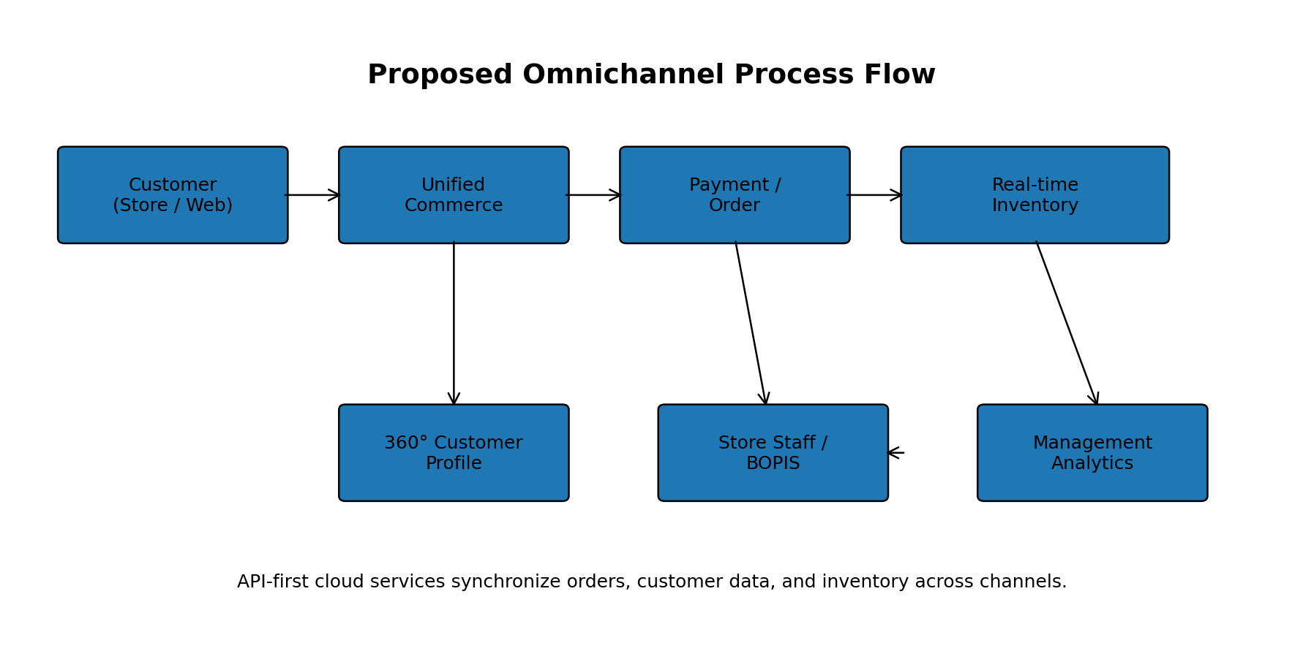
The process flow below illustrates the proposed future state. Customers can purchase through store or web channels while the unified commerce layer coordinates orders, payments, customer profiles, and real-time inventory. Store staff gain inventory visibility and BOPIS support, while management receives consolidated analytics.
- Implementation roadmap
Key milestones for implementation within nine months

Milestone | Timeline | Description
Initiation & design | Month 1 | Confirm requirements, governance, architecture, integrations, and rollout plan.
Configuration & integration | Months 2–3 | Configure Shopify Plus and Square POS; build REST API integrations and unified data flows.
Migration rehearsal & testing | Months 4–5 | Run data migration dry runs, checksum validation, functional testing, performance testing, and security checks.
Training & pilot | Months 6–7 | Complete staff upskilling within eight weeks and pilot the solution in a limited store group.
Phased rollout | Month 8 | Deploy in waves, validate checkout speed, inventory synchronization, BOPIS, and offline procedures.
Stabilization & handoff | Month 9 | Resolve defects, monitor SLA/KPIs, complete operational handoff, and review readiness for expansion.

